

Sandra Kopp, M.D.

Date:

HAIR LOSS

Name: DOB:

Race: Height: Weight:

1. When did you last have a normal head of hair? __________
2. 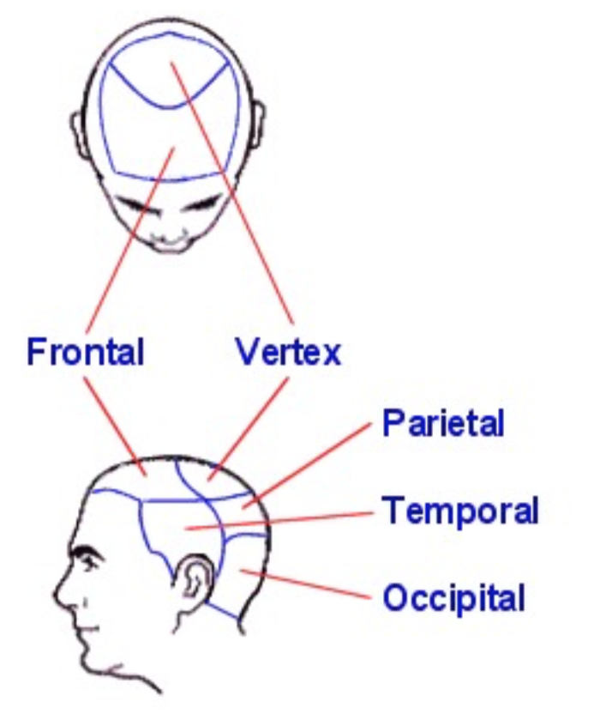Was onset of hair loss sudden or gradual?
3. Is your hair coming out “by the roots” or is it breaking off?

(Please shade in areas of location of hair loss on the map to the right.)

1. Is your hair thinning or is it shedding?
2. How often do you wash your hair?
3. What hair products do you use?
4. Do you use hot rollers, ponytails, braids, twists, locks, extensions, or weaves? How long? How often?

If you have a weave, is it sewn in or glued?

1. Do you use hot combs, press and curl, curling irons, flat irons or otherwise apply direct heat to your hair?
2. How often do you blow dry your hair?
3. What type of hair chemicals do you use for your hair?

Hair dye? Name:

Relaxer? Name:

Is it a relaxer that contains lye? Do you have a permanent wave?

Name: How long? How often?

1. Does your scalp itch? Little Moderate A lot (Circle)
2. Do you get sores in your scalp? Yes No
3. Do you have dandruff? Yes No Psoriasis? Yes No
4. What medications are you allergic to?
5. What medications do you take ?

Do you use OTC herbs or supplements? Yes No

Name:

1. If you are on birth control pills, which one?

Have you recently started? When?

Or stopped your birth control pills? When?

1. Are you on any other type of hormone treatment?

Which one? How long?

Or stopped? When?

1. If applicable, are your menstrual periods regular? Normal flow?

If not, what is happening? How long?

1. Have you gone through menopause? Age?
2. Are you on any type of weight loss diet?

Are you on a low protein diet?

Any dietary restrictions?

Are you a vegetarian (type)?

1. Any hair loss in men in your family? ­­­­

Any hair loss in women in your family?

Any family history of thyroid disease, anemia, or lupus?

1. What medical problems do you have?

1. Have you had a hysterectomy? □ Yes □ No
2. Do you have?
   1. Severe headaches □ Yes □ No
   2. Double vision □ Yes □ No
   3. Excess facial hair □ Yes □ No
   4. Excess body hair □ Yes □ No
   5. Cystic Acne □ Yes □ No
   6. Discharge from breast □ Yes □ No
   7. Deepening of voice □ Yes □ No
   8. Enlargement of clitoris □ Yes □ No
   9. Polycystic ovary disease □ Yes □ No
3. Have you had in the last 3-12 months?
   1. High fever □ Yes □ No
   2. Childbirth □ Yes □ No
   3. Severe infection □ Yes □ No
   4. Flare of chronic illness □ Yes □ No
   5. Major surgery □ Yes □ No
   6. Over or under active thyroid □ Yes □ No
   7. Low protein diet □ Yes □ No
   8. Low iron in blood □ Yes □ No
   9. Severe psychological stressor □ Yes □ No
   10. Death of loved one □ Yes □ No
   11. Start or stop birth control pills □ Yes □ No
   12. Start or stop hormone treatment □ Yes □ No
   13. Start or stop beta blocker medication □ Yes □ No
4. Do you see a rash in your scalp or on your face?

If yes, please describe.

1. Treatments previously tried? (Rogaine, Vitamins, Shampoos, etc.)

__________________________________________________________________________________

___________________________________________________________________________

1. Any biopsy or blood work done for hair loss? ­­­­­____________________________________